Mass Software Upgrade (MSU)

Schneider Department: | AOCI | Document Identification: | AOCI/PMP/DE/T/6
Project Code: | xxxxxx

Executive definition & objectives: Describe the architecture at component level and its physical implementation. It is a refinement of the Product Concept Design.
This document prepares the component implementation and is required for the implement state gate for critical components only. It is created after DO and must be updated at IMPLEMENT as it will serve as input for maintenance and future evolutions.

Deliverable Name | Technical Specification | Stage Gate
Deliverable Name | Technical Specification | OPEN
Deliverable Name | Technical Specification | SELECT
Deliverable Name | Technical Specification | DO
Deliverable Name | Technical Specification | IMPLEMENT
Deliverable Name | Technical Specification | PRODUCE
Deliverable Name | Technical Specification | SELL
Deliverable Name | Technical Specification | CLOSE

Status | Draft | In Review | Official

Roles | Function | Name
Authors
Reviewers
Approvers
Refer to applicable Roles Assignment List to fill this table

Template Revision History
Version | Date  dd/mm/yyyy | Author(s) | Modification Details
1.0 | 01/07/2010 | AOCI Quality

Document Revision History
Version | Date  dd/mm/yyyy | Author(s) | Modification Details
V1.0 2008/03/18 J.Templeton Fist Official Version Embed final feedback file for Official versions

V1.0 2008/03/18 J.Templeton Fist Official Version Embed final feedback file for Official versions

Linked Documents
Name | Reference | Author | Comments

Show hidden text to read the help (click on standard tool bar command: ¶)

General guidelines to elaborate this document

1. Tailoring the template:
- The template scheme and proposed content intend to help the author in the elaboration of the document: they match our processes definition and way of work and should apply well in most cases.
- Nevertheless, the author has to adapt the proposed content in case of specificities. When some proposed chapters are not applicable, the recommendation is to keep them inside the final document with a short justification of the inapplicability. When extra information is needed, the author is encouraged to structure and document it in the most convenient way.
- In any cases, filling a document rigorously respecting its template is not an objective in itself. It is preferable to reach the intended goal and function of the document than to fit to an inappropriate template scheme.
- A document is appropriate for its intended use if it is:
- Complete: each expected content is present
- Correct: each content is exact
- Consistent: the document fits other related data

2. Updating automated fields:
- Three automated fields must be updated by the author (menu ‘File-Properties-Summary tab):
- The field ‘Title’ is used for the ‘Project Name’
- The field ‘Subject’ is used for the ‘Deliverable Name’ (ex.: “Project Management Plan”, “CANopen Field Bus Product Specification”)
- The field ‘Comments’ is used for the ‘Version’ of the document
- Then update the fields values inside the document:
- Click inside the document
- key CTRL-A (‘Select all’)
- Key F9 to refresh.
- Double-click on page 2 or following Header or Footer
- key CTRL-A (‘Select all’)
- Key F9 to refresh
- The filename of the document is automatically inserted in the document header (ex: “Mirano Project Management Plan.doc”, “CANopen Field Bus Product Specification.doc”)

3. Versioning rules:
Use the following rules to manage the document versions:
- Draft and In Review: vX.X (ex: v0.1, v0.2, v0.3 increment at each published version)
- Official: vX.X (ex: major changes: v1.0, v2.0, v3.0… minor changes: v1.1, v1.2, v1.3…)

4. Filling the Roles table (front page):
Refer to the applicable Roles Assignment List document that gives default Function assignment for Authors, Reviewers and Approvers (stored in the same repository as the documents templates). Keep this table up-to-date for each document Version.

5. Reviewing the document:
- Documents must be reviewed to transform them from the Draft state to the Official state.
- Draft: the document is not mature enough to enter the Review Process
- In Review: the document is in sufficient elaboration level so that Reviewers verify it and decisions are taken for solving found issues (or selection among alternatives)
- Official: the actors of the performed Review Process agreed that the document satisfies the expected quality criteria for its intended use: Completeness, Correctness, Consistency with other project data
- The author (in collaboration with the Project Manager / Review Leader) selects Reviewers and Approvers according to the default Roles Assignment List and involve them in the applicable review process (reference documents are accessible in the Documents Templates repository)
- The final feedback file is preferably embedded inside the Official document (template for Feedback form is accessible in the Documents Templates repository)

6. Template revision history:

Table of Contents
1 Functional architecture 7
1.1 Scenarios 9
1.2 Components internal requirements 9
1.2.1 Software components <component name> 10
1.2.2 Hardware components <component name> 10
1.3 External detailed interface component 10
1.3.1 Software interfaces <component name> 11
1.3.2 Hardware interfaces <component name> 11
2 Component Architecture 12
2.1 Software Component <component name> 12
2.1.1 Major classes / internal functions identification 14
2.1.2 Major internal Interfaces identification 15
2.1.3 Software Component High level design 15
2.2 Hardware Component <component name> 16
3 Detailed Component Design 17
3.1 Software Component <component name> 17
3.1.1 Component view 17
3.1.2 Execution view 18
3.2 Hardware Component <Component name> 18
4 Component characteristics 23
4.1 Software Component <Component name> 23
4.2 Hardware Component <Component name> 23
4.3 Metrics 23
5 Key Points and Risks 24
5.1 Design & implementation decisions 24
5.2 Known limitations 24
5.3 Risks 24
6 Objects to be produced 24
6.1 Software Component <Component name> 24
6.2 Hardware Component <Component name> 24

Introduction
This Software Design Specification document defines the High Level Design for the Mass Software Upgrade (MSU) Server Computer Software Configuration Item (CSCI). This document provides the design details for scanning the devices in the network, authenticating the user for transaction with the devices, Software/Firmware Upgrade/Downgrade/Force Upgrade process.

MSU Overview
Mass Software Upgrade [MSU] is a reliable network protocol for carrying out simultaneous firmware/software upgrade process of a large number of systems. It uses a combination of multicast and unicast datagram protocols for data transfer. Reliability is achieved by selective re-transmission of the desired portion of the data upon request from the systems participating in the upgrade process.
The objectives of Mass Software Upgrade process are:
- To simultaneously upgrade firmware/software/Application/Files on many systems.
- To encourage indirect or implicit (via programs) use of remote computers.
- To transfer data reliably and efficiently even on high traffic network.
- To Automatic recovery of upgrade process even in cases of network re-establishment.

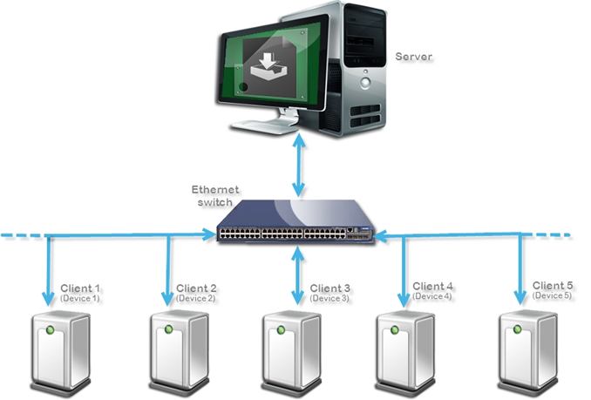

Figure 1 : MSU Solution Architecture

References

Index | Document Title | Document ID | Version
1 | MSU Offer Requirements |  | V 01.0
2 | MSU Protocol Specification |  | V 1.0
3
4
5

High level design
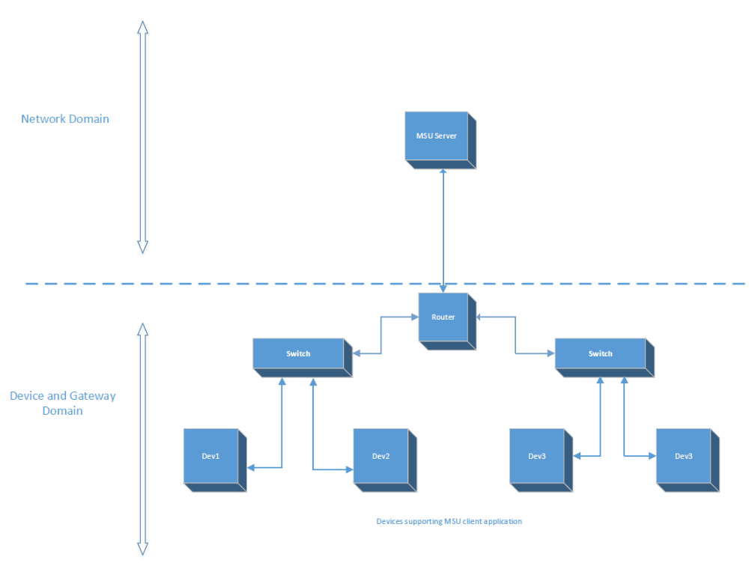

MSU high level design can be neatly segregated into the network domain and the Device and the Gateway domain.

- The Network Domain comprises of :

- MSU Server – This system running the MSU server application and hosting the archive files.

- The Device and the Router Domain:

- MSU Leech Device – The device supporting MSU client application and listening on the default Multicast IP.

- Router – Multicast enabled router to permit the flow of MSU packets.

Functional architecture
You will define in functional architect all the materials to construct the component architecture:

- Components uses cases
- Components requirement
- A detailed description of external components interfaces

The detailed components architecture is defined during implementation phase.

Component requirements come from MIR/SRS derived / allocated to components and internal component requirements
Component use cases come from a refinement of system use cases or new internal component uses cases necessary define an unambiguous component dynamic behavior specification.
Detailed external description come from a refinement of interface requirements needed by other components and identified during the architecture phase as described in Product Concept Design.

MSU Solution is Client-Server Architecture based Solution, where the Server is executed on a PC and clients are executed on the Hardware devices. Clients and Server are connected by network and they communicate using UDP Socket (multicast & unicast messages).

MSU client application is applied as a plug-in component in the main application. It must be invoked as a separate thread.
It interacts with the network interface and file system to manipulate data and build the image file.

It performs the following functions

- Responds to the server discovery request.

- Performs the authentication based
- Username , Password (Mandatory)
- IP white-list (Optional- Application need to register us same)
- MAC address (Optional- Application need to register us same)

The application has to provide “white list” and “MAC list” entry to MSU on registering for these feature else MSU will bypass these step while processing the MSU packet. Application uses registering function to provide the list. This feature may not require if device is already taking care source authentication/validation by some other means.

- Updates the socket based on the Notification message.

- Interacts with the file system to build the image file.

- Once the file transfer is complete, it initiates the complain mode for missed data packets.
- SCM – Sequences lost in a chunk.
- CCM- Chunks lost during file transmission

- Performs a CRC check on the assembled file.

- If the CRC check passes, it performs post file transfer command to commit the upgrade with new image file.

- On receiving the abort message, it disengages from the upgrade process and performs a loop-back.

- It responds to the status check message from the server.

.

MSU System Interaction diagram

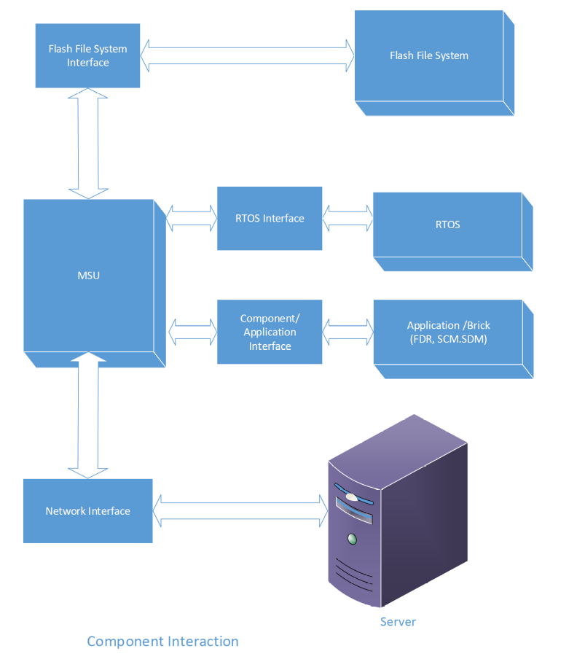
MSU interaction diagram

MSU core interact with BSP, RTOS and File system using interfaces. Application need to define those interfaces and MSU core will be use them during upgrade process. There will be no direct call between MSU code and platform.

Scenarios
Describe formal use cases if it is required or informal scenario that describes the expected dynamic behavior of the components.

ID | Headline | Description
UC1 | Firmware upgradation | PLCs ,HMI and motor control devices which are installed in high numbers in plants like solar power plant, food processing industries etc need to upgrade firmware often. MSU can be used to update all the devices at the same time.
UC2 | Application download | Frequently the application program of PLCs and HMIs are in need to update. MSU can be used to update all the devices at the same time.

Components internal requirements
- Describe formal (TRS) or informal component requirements that will drive the design of these components and will the inputs for unit test cases and verification test cases
  - Client on Scan command
    - Client MUST respond scan command to server as per MSU Specification
    - Client MUST respond the device identification as per MSU Spec
    - Client MUST respond MSU protocol parameters
  - Client on server and user authenticate
IP White Listing: MSU client must provide a mechanism to register this service. Platform application will register this service by providing the list of “IP White list” during the registration else MSU must by pass this step.
In case the platform application register this service then Client MUST validate the source of incoming packet at the time arrival and before process to next level and allow only packets those are coming from listed.
The IP white list must be none editable/read only for MSU services. List modification is subjected to platform application, MSU services will completely independent of list contain its only bother of format in which it’s expect wrt to MSU Specification.
The List size must be in range of MIN =5 and MAX= 10 entry.
User Authentication: Client MUST validate User ID and Password before starting the upgrade process. Unauthorized user MUST be denied to start the process. MSU must provide a service to register a function which will be defined by platform application. MSU core application will call this function to validate the authenticity of user. On successful user authentication MSU allow to use their services else denied.
MSU Server send Transaction id with the user information in connect message (more detail can see the frame format in MSU Specification V1.0). MSU client must save this transaction id for future communication. MSU client allows only those packets to enter who has same transaction id else drops/rejects.
  - MSU Configuration
    - All the configuration data required for MSU client MUST be by platform application. MSU client does not own any configuration data apart from MSU protocol parameter.
- Client Upgrade Process
- Client MUST validate the transaction id on each packet arrival.
- Client MUST join to the multicast address in case if it is interested in the upgrade process.
- Client MUST send unicast messages to the server IP address received.
- Client MUST listen to the port number which is received from Server.
- Client MUST store the file received in the path location sent by Server.
- During the communication timeout Client MUST exit from the current process and become available for the next update process without participating in the current update process. The status of client should be FAIL until the beginning of the next cycle.
- Client MUST keep track of all received MSU sequence within a chunk.
- During the SCM wait time the client MUST request for retransmission of sequences from server those are missed.
- Client MUST keep track of all chunks send by server. So that at end of the file transfer it can find out if any chunk missed.
- Client MUST go into the CCM after the transfer completed message is received, incase if there are chunks missed.
- Client MUST do the CRC check of the file received after the transfer completed message if it does not want to participate in CCM otherwise it does the CRC check after the CCM is completed.
- Client upon receiving the abort request MUST undo all the operations after which the client should be possible to resume the normal operations.
- The client MUST send the two frames of status message to server after the CRC calculation. The two frames are sent in an interval 10 ms.
- Client must provide the current upgrade status on the request from server.
- Server must use post file transfer command to commit the upgrade. In case client upgrade does not need any post file transfer command than this can be optional for them. MSU client provides the services to register these command and it’s up to platform to decide which service they want to consume.( please see the MSU Protocol specification V1.0 for more detail on these services).

Software components <component name>
You can use the proposal below by selecting it and changing the style from hidden to normal:
ID | Headline | Description
TRS1 | Name variable should be limited to 256 character | No name longer than 256 char. If longer it must be truncated

Hardware components
You can use the proposal below by selecting it and changing the style from hidden to normal:
ID | Headline | Description
HW1 | Server | PC on which MSU Server is running and initiate the upgrade process.
HW2 | Client | MSU Client is the device/system which expect the files from Server
HW3 | Ethernet Network | MSU client and server must connected on Ethernet network and must support UDP/IP protocol
HW4 | Router | Device which connects multiple sub network in one network. Router must support IGMP to manage the multicast traffic.
HW5 | Switches | Ethernet switches which connects more then on device within a subnet.
HW6 | Gateway | Device which connects the multiple network
HW7

External detailed interface component
Refinement of components external interface as described in “Product Concept Design “
If you have interface to hardware components they should be described here.

Software interfaces <component name>
You can use the proposal below by selecting it and changing the style from hidden to normal:

Name
Example
Description
Used by
Input parameters | Description | Type
Output parameters | Description | Type
Return values | Description | Type
Error codes | Description
< Text to write >

Hardware interfaces <MSU Client>
Describe here your interfaces to hardware
Ethernet Port – To communicate with the server.

Component Architecture
.
This section covers the internals of the MSU Client Software architecture. It also covers classes or functions identification, their interfaces, and integration.

Software Component <MSUClient>
MSU client application has been designed as a state machine.
The Client switches from one state to other state either by internal or external event. Internal events are generated by MSU client in case of error occurs during initialization, configuration or processing message. External event are the commands send by MSU Server. Every state have entry and exit condition coming from server initialization… …. Init and Config are the two state driven by internal event reset of all state driven by external event component, once raised, listens on a default multicast address and based on the inputs from the server switches between different stable states.
The MSU states are below.
Init state
Entry condition:
- Power cycle/ restart service
Exit condition:
- Initialize all local and global variable to their default values
- Clear all memory pool to
Config State
Entry condition
- Successful execution of Init state
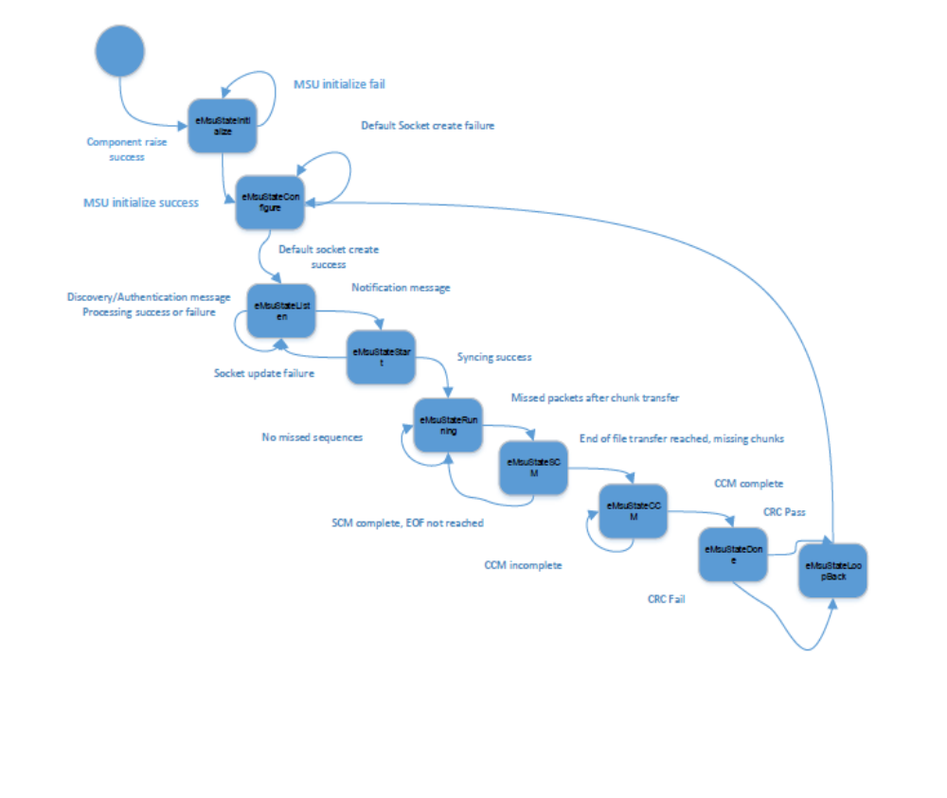

The component once raised, goes for initialization (eMsuStateInitialize), where all the variables relevant to the current upgrade cycle are initialized or reset depending on the expected behavior. On initialization success, the state changes to eMsuStateConfigure Here a socket is created to listen on the default multicast address and port number (eMsuStateListen).
On this default address it listens for Discovery and authentication requests without changing the state until it receives the notification message (eMsuStateStart).
Once the component receives and successfully processes the notification message, it updates the socket to the new multicast address contained in the notification message and the state changes to eMsuStateRunning.
The eMsuStateRunning state meets the data handling requirements.
After all the sequences in the Chunk have been received and there are missed sequences the device goes into eMsuStateSCM. In case, there are no missed packets, the state transfers back to eMsuStateRunning to copy the next incoming packets belonging to the consecutive chunks. Else, the respective missing sequences of the chunk are read and written to the file.
Once the EOF has been reached and SCM for the last chunk is complete, the state changes to eMsuStateCCM. This state handles the CCM requirements.
In the event of missing chunks, a message containing the missed chunk bit map is sent to the server. The respective packets are then read and the file is assembled.
The system transfers to eMsuStateDone once CCM is complete and all the missing packets have been read. The CRC is checked and irrespective of CRC pass or fail, the system releases the resources and performs a loopback(eMsuStateLoopBack). If the CRC passes, the upgrade status is updated accordingly.

From the state eMsuStateLoopBack, the device goes back to eMsuStateConfigure and listens on the default multicast IP, and waits to participate in a new upgrade process.

If the system receives an Abort message, irrespective of the state, the device must disengage from the upgrade process and perform a loopback to the default multicast IP.

State | Event | Next State | Upgrade Status
eMsuStateInitialize | Initialize success  Initialize failure | eMsuStateConfigure  eMsuStateInitialize | eMsuUpgradeFailed
eMsuStateConfigure | Default socket create success | eMsuStateListen | eMsuUpgradeFailed
eMsuStateConfigure | Default socket create failure | eMsuStateConfigure | eMsuUpgradeFailed
eMsuStateListen | Sync message recieved | eMsuStateStart | eMsuUpgradeFailed
eMsuStateListen | Sync message process failure | eMsuStateListen | eMsuUpgradeFailed
eMsuStateStart | Socket update success | eMsuStateRunning | eMsuUpgradeFailed
eMsuStateStart | Socket update failure | eMsuStateListen | eMsuUpgradeFailed
eMsuStateRunning | Data transfer complete  Packets Missed | eMsuStateSCM | eMsuUpgradeFailed
eMsuStateRunning | Packets Not missed | eMsuStateRunning | eMsuUpgradeFailed
eMsuStateSCM | Missed Packets | eMsuStateSCM | eMsuUpgradeFailed
eMsuStateSCM | End of file reached | eMsuStateCCM | eMsuUpgradeFailed
eMsuStateCCM | CCM complete | eMsuStateDone | eMsuUpgradeFailed
eMsuStateCCM | CCM incomplete | eMsuStateCCM | eMsuUpgradeFailed
eMsuStateDone | CRC verification pass | eMsuStateLoopBack | eMsuUpgradePassed
eMsuStateDone | CRC verification fail | eMsuStateLoopBack | eMsuUpgradeFailed
eMsuStateLoopBack | Release resources | eMsuStateConfigure | eMsuUpgradeFailed
Any state | Abort Message | eMsuStateAbort | eMsuUpgradeFailed
eMsuStateAbort |  | eMsuStateLoopBack | eMsuUpgradeFailed

Chapter 2 is optional and is a base for chapter 3.
If you have a detailed component architecture you may not need the intermediate works.

Major classes / internal functions identification
For object oriented design, define what are the potential classes and their responsibilities and collaborators.
You can use a CRC Card to define it as described below:
Function Name | msuParseDiscoveryRequest
Parameters | pMsg,msgSize,pDiscoverRequest
Structures Name | MSUDiscoveryRequestPdu,MSUCmd,VerInfo
Attributes
Name |  | Description
pMsg |  | Device discovery request message
msgSize |  | Size of discovery request message
pDiscoverRequest |  | Pointer to discovery request Pdu
Structure |  | MSUDiscoveryRequestPdu
Command |  | MSUCmd
isRange |  | UINT8
Reserved |  | UINT8
versionInfo |  | VerInfo
StartRange[10] |  | UINT32
endRange[10] |  | UINT32
Structure |  | MSUCmd
Opcode(4) |  | UINT8
Subcode(4) |  | UINT8
Structure |  | VerInfo
versionIP(1) |  | UINT8
versionProtocol(3) |  | UINT8
Reserved(4) |  | UINT8

Function Name | msuDiscoveryResponseMsgCreate
Parameters | discoveryRequestPdu,msuDiscoveryResponse,dataPayloadSize
Structures Name | MSUDiscoveryRequestPdu,MSUDiscoveryResponsePdu,
Attributes
Name |  | Description
discoveryRequestPdu |  | MSU discovery request pdu pointer
msuDiscoveryResponse |  | MSU discovery response Pdu data will be updated in this buffer
dataPayloadSize |  | Data payload size will be updated
Structure |  | MSUDiscoveryRequestPdu
Command |  | MSUCmd
isRange |  | UINT8
Reserved |  | UINT8
versionInfo |  | VerInfo
StartRange[10] |  | UINT32
endRange[10] |  | UINT32
Structure |  | MSUDiscoveryResponsePdu
command |  | MSUCmd
GroupId |  | UINT8
AuthenticationLevel |  | AuthLevel
versionInfo |  | VerInfo
deviceID[10] |  | UINT32
hardwareIDTag |  | FieldNameTag
productIDTag |  | FieldNameTag
productNameTag |  | FieldNameTag
modelNameTag |  | FieldNameTag
vendorIdTag |  | FieldNameTag
firmwareVersionTag |  | FieldNameTag
revisonTag |  | FieldNameTag
deviceLocTag |  | FieldNameTag
devMSuParam |  | FieldNameTag
reservedUser[3] |  | UINT8
Structure |  | MSUCmd
Opcode(4) |  | UINT8
Subcode(4) |  | UINT8
Structure |  | VerInfo
versionIP(1) |  | UINT8
versionProtocol(3) |  | UINT8
Reserved(4) |  | UINT8
Structure |  | FieldNameTag
isFieldPresent(1) |  | UINT8
fieldLength(7) |  | UINT8
Structure |  | AuthLevel
IsClient(1) |  | UINT8
IsMaster(1) |  | UINT8
IsAuthRequired(1) |  | UINT8
Level(1) |  | UINT8
Reserved(4) |  | UINT8

Function Name | msuParseAutheticationRequest
Parameters | pMsg,msgSize,pAuthenticationRequest
Structures Name | MSUAuthenticationRequestPdu,
Attributes
Name |  | Description
pMsg |  | Device discovery request message
msgSize |  | Size of discovery request message
pAuthenticationRequest |  | Pointer to authentication request Pdu
Structure |  | MSUAuthenticationRequestPdu
Command |  | MSUCmd
Reserved[3] |  | UINT8
versionIP |  | VerInfo
serverIP[10] |  | UINT32
TransactionID |  | UINT32
MACAddr[6] |  | UINT8
FileLength |  | FieldNameTag
hardwareIDTag |  | FieldNameTag
productIDTag |  | FieldNameTag
modelNameTag |  | FieldNameTag
PasswordTag |  | FieldNameTag
UsernameTag |  | FieldNameTag
FWVersion |  | FieldNameTag
SWVersion |  | FieldNameTag
vendorIdTag |  | FieldNameTag
productNameTag |  | FieldNameTag
Structure |  | MSUCmd
Opcode(4) |  | UINT8
Subcode(4) |  | UINT8
Structure |  | VerInfo
versionIP(1) |  | UINT8
versionProtocol(3) |  | UINT8
Reserved(4) |  | UINT8
Structure |  | FieldNameTag
isFieldPresent(1) |  | UINT8
fieldLength(7) |  | UINT8
For functional design describe here the main functions (responsibilities, collaboration …) and global objects

Major internal Interfaces identification

Software Component High level design

< Text to write >

Hardware Component <component name>
< Text to write >

Detailed Component Design

Software Component < msuParseDiscoveryRequest >

msuParseDiscoveryRequest function receives the discovery message from the socket and stores it in the DiscoveryRequest buffer.

It gets the ip address of the client from the FDR component and check whether it is in the range of the ip address sent by server discover request.

It returns value TRUE if the client ip is with in the range else it returns FALSE

Component view

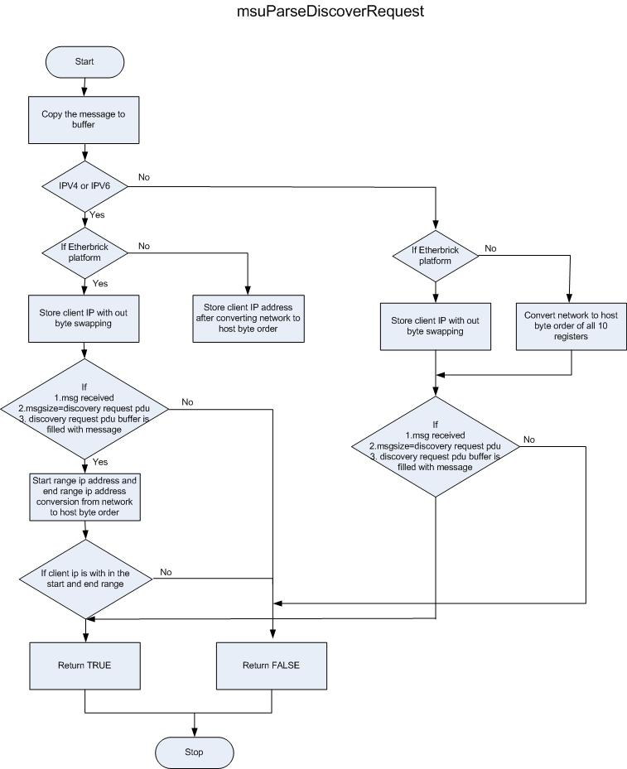
Refine the high level design. Using a detailed class diagrams or a detailed function blocks diagrams for go to the sub-component internal.
Example: If you use a UML modeler you can add attributes & methods description to the high level design.

- Dynamic behavior
Modeling dynamic behavior using necessary UML diagrams as sequence diagrams / communication diagrams / state chart / activity diagrams
- Describe tasks & processes
Provide a description of tasks, threads & processes and their interactions with objects.

Software Component<msuDiscoveryResponseMsgCreate >

If the device is with in the ip range or the device id sent by server the client sends the discovery response by the function msuDiscoveryResponseMsgCreate.

The device information such as hardware id , product name , model name,vendor id,firmware version and revision are read from the device and those informations are sent to the server in the message format defined for discovery response with Opcode 2 and Subcode 2.Also the MSU communication parameters such as sequence delay , SCM and CCM delay , SCM and CCM retry count and communication timeout is sent as a part of the response.

Component view
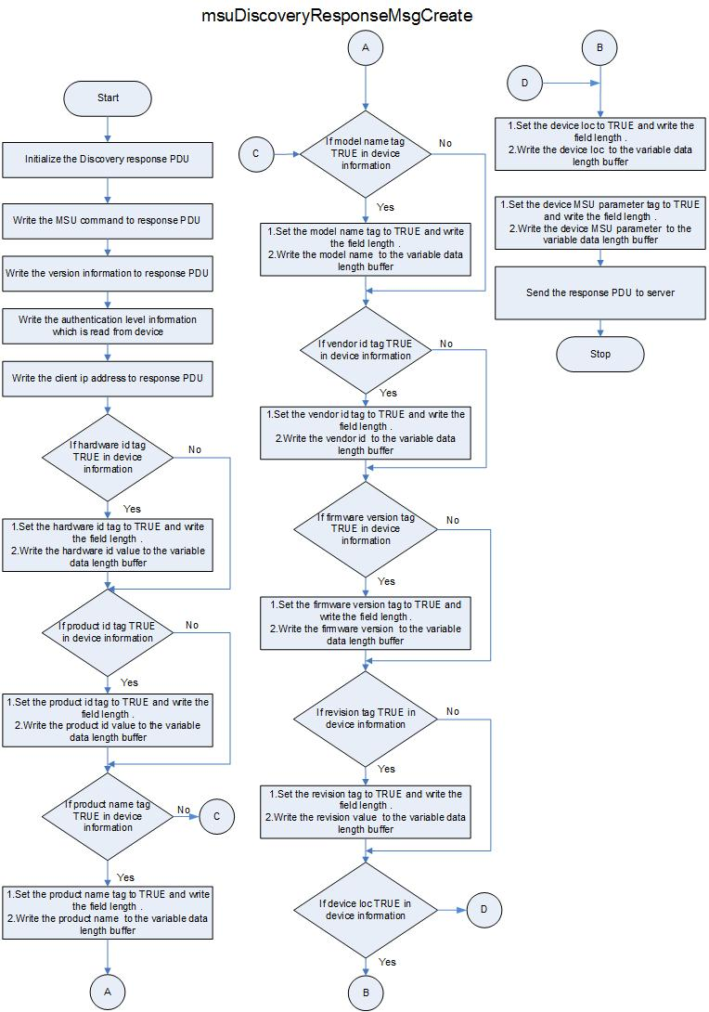

Software Component <msuAuthenticationRequest>
msuAuthenticationRequest receives the message and stores the content in the pAuthenticationRequest buffer. It verifies the server ip address with the socket ip and with the white listed ip address. If the server ip is valid , it reads the username and password , decrypts it and verifies it against the username and password received from the packet.

msuAuthenticationRequest function sends the authentication response with error code 0, if the credentials are valid else it sends the response with error code.

Error Codes and Description Table

Error Code | Error Subcode | Description
1 | 02 | Server ip not matching with socket ip or not a part of whitelisted IP
1 | 03 | Invalid credentials
1 | 04 | FileName mismatch
1 | 05 | Hardware ID mismatch
1 | 06 | Transaction ID is 0

Component view

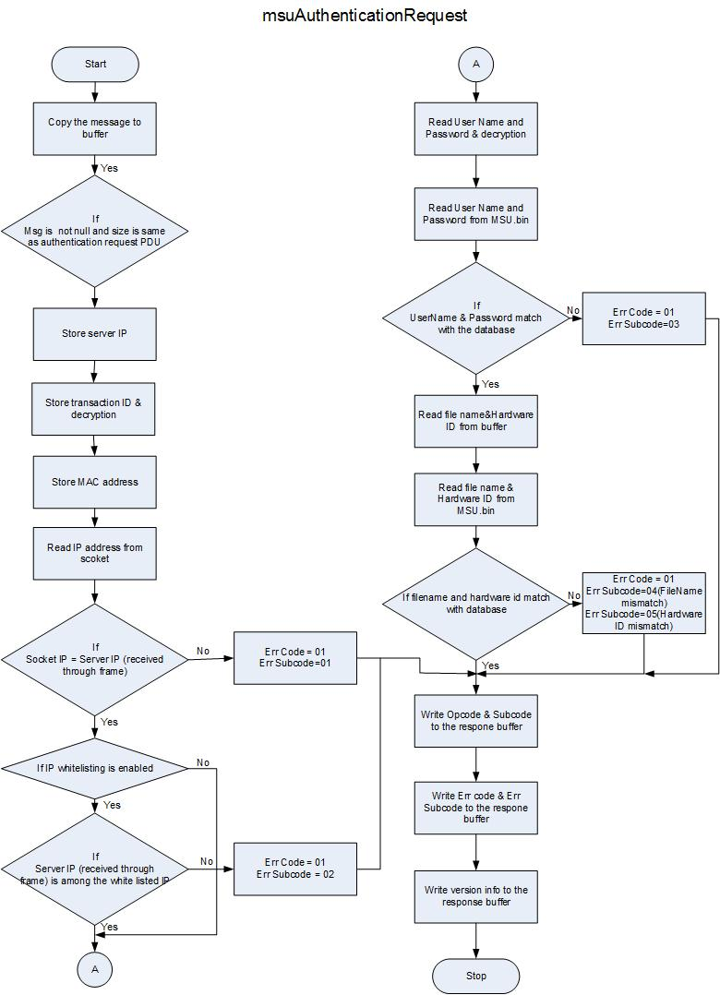

Software Component < msuSocketProcessSyncMessage >
The notification/Sync message from the server contains important information pertaining to the file upgrade process, such as the filename, the length, the number of chunks, the checksum value etc, but most importantly the updated notification address and the port on which the device must listen to get the data packets.
Once the device receives the packet, it parses and reads the data and updates the relevant fields.
If there is any ambiguity in the information contained in the packet, the Global variable is set to the respective error value and no further checking is performed. In this case the device continues to listen on the default multicast address.
If the parsing is successful, then the device is configured to listen on the updated socket.
The following are the error codes defined.

Name | Value | Description
MSU_UPDATE_STATUS_FILE_VALUE_NULL | 12 | Number of files are zero.
MSU_UPDATE_STATUS_FILE_SIZE_ZERO | 13 | File size is zero.
MSU_UPDATE_STATUS_CHUNKCOUNT_ZERO | 14 | Chunk count for the current file transfer is zero.
MSU_UPDATE_STATUS_SEQLIMIT_ZERO | 15 | The sequence limit for the current file transfer is zero.
MSU_UPDATE_STATUS_SEQLIMIT_EXCEEDED | 16 | Number of sequences by the chunk exceed permitted limit
MSU_UPDATE_STATUS_SEQSIZE_ZERO | 17 | The size of one sequence is zero.
MSU_UPDATE_STATUS_SEQSIZE_EXCEEDED | 18 | The size of one sequence exceeds the permitted limit.
MSU_UPDATE_STATUS_SERVER_IP_ZERO | 19 | The updated address is zero.
MSU_UPDATE_STATUS_SERVER_CM_IP_ZERO | 20 | The updated complain mode address is zero.
MSU_UPDATE_STATUS_PORT_ZERO | 21 | The port value is set to zero.
MSU_UPDATE_STATUS_CM_PORT_ZERO | 22 | The complain mode port value is zero.
MSU_UPDATE_STATUS_TRANSACTIONID_ZERO | 23 | The transaction Id is set to zero.
MSU_UPDATE_STATUS_CRC_ZERO | 24 | The checksum of the file is zero.

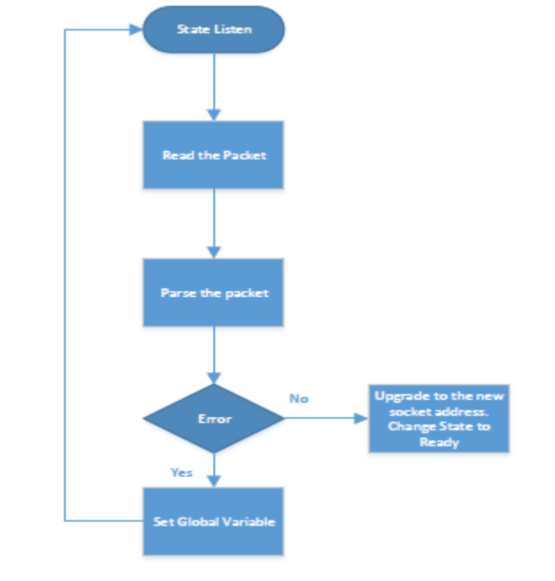

Software Component < msuPasrseDisconnectMessage>
This function in turn calls the function that processes the read packet and sends the disconnect message response. If the parsing is successful, the transaction Id specific to that upgrade cycle must be reset. This value is read and populated during the server connection establishment and is unique to that upgrade cycle.
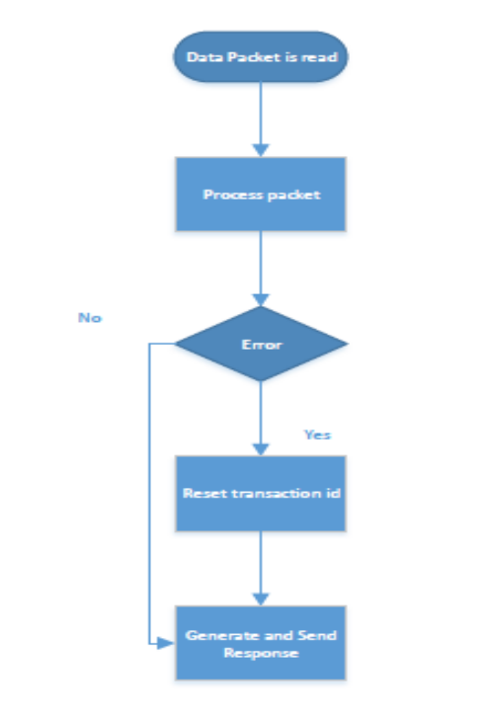

Software Component < msuDisconnectMsg>
This is the function that handles the packet parsing. It checks the validity of the packet to ensure that it originates from the authenticated source. If there is any mismatch at transaction id level, the authentication level or if the server IP is not what is expected the connection is not closed.
To reflect the cause of the error, a global variable is set to the right value.
If there are no errors, then the global variable is consciously set to zero to make sure that for consecutive disconnect message return the correct error code on parsing.

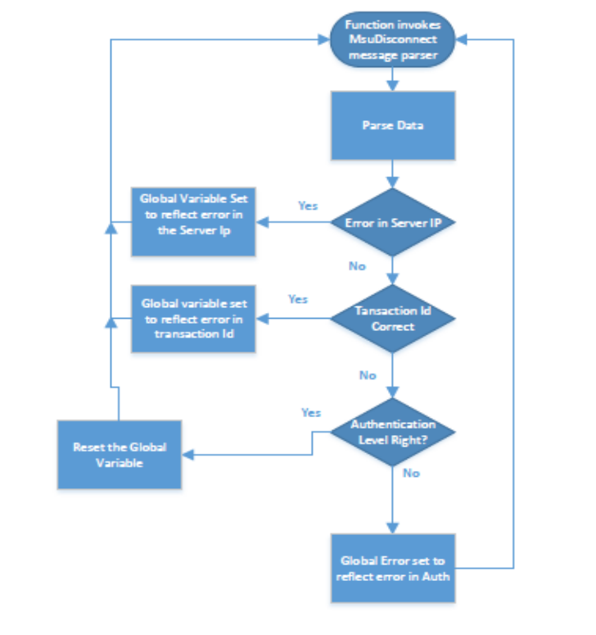

Software Component < msuDisconnectMsgResponseCreate>
This function creates the disconnect message response. Based on the global variable being set or not, the correct response is generated

Software Component < msuSendDisconnectResponse>
This function sends the Disconnect message response generated by the msuDisconnectMsgResponseCreate.

Software Component <msuHandleMcastPacket>
This function is used to parse the multicast data packet received from the server. This function reads the data and stores it in RAM/FLASH based on the writing scheme and sets the bit for the received sequence in the sequence bit map.
If the end of chunk notification is received from the server this function checks for the missed sequences.
In the event of missing sequences, this function generates the SCM message and sends it to the server.
In addition, it also checks for the end of file and changes state to CCM .
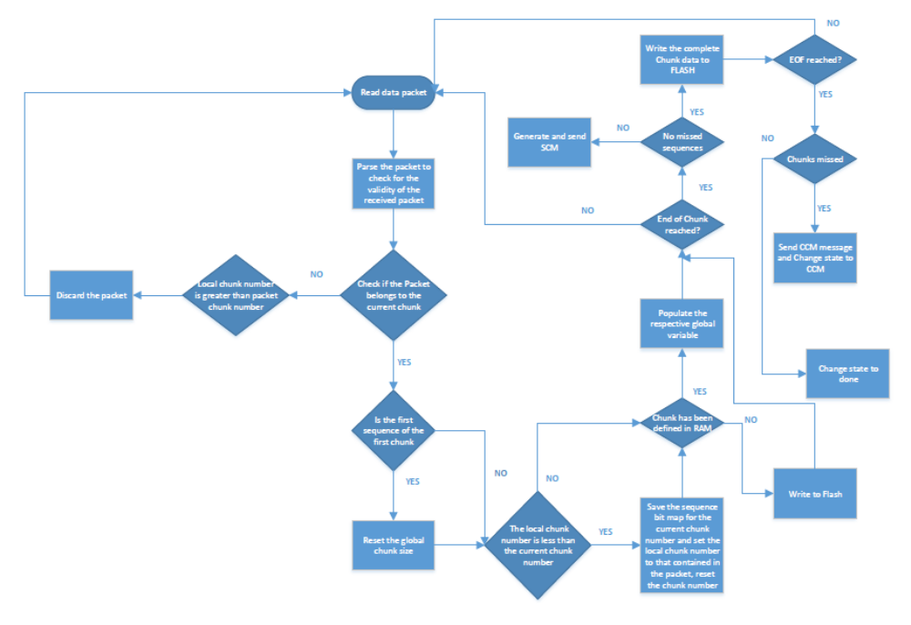

Software Component < msuHandleScmMcastPacket>
After reception of each chunk, client checks whether any sequences missed in that chunk, if missed
Then client enters into SCM mode and waits to receive missed sequence packets from server.
This function receives missed sequence packets and writes into a file. If all missed sequences are received
Or sequence packet received from different current chunk number other than current chunk then it writes the current chunk to the file and changes the state to Running or CCM state depending on the previous state.

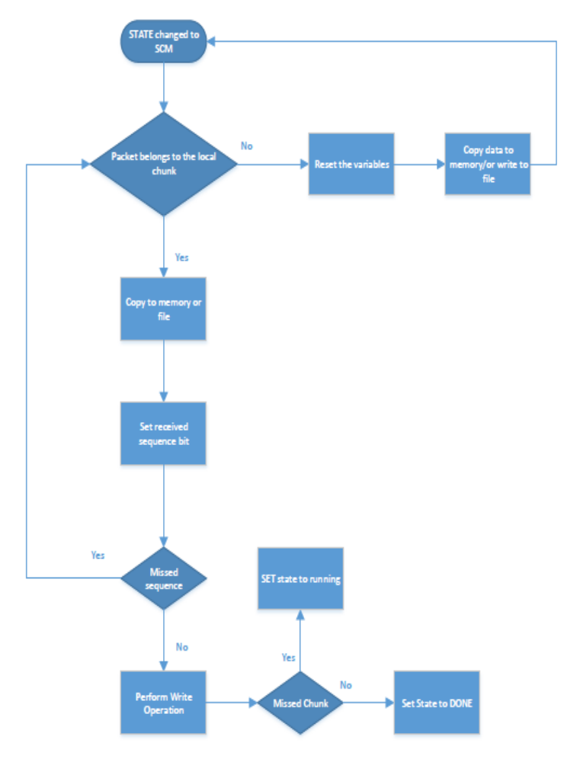

Software Component < msuHandleCcmMcastPacket>
After file transfer completes, client checks whether any chunks are missed in that file, if chunks missed
then client enters into CCM mode and waits to received missed chunks from server.
After receiving each chunk it checks for missed sequences in the chunk, if any then it enters into SCM state,
after receiving missed sequences it comes back to CCM state to receive other missed chunks.
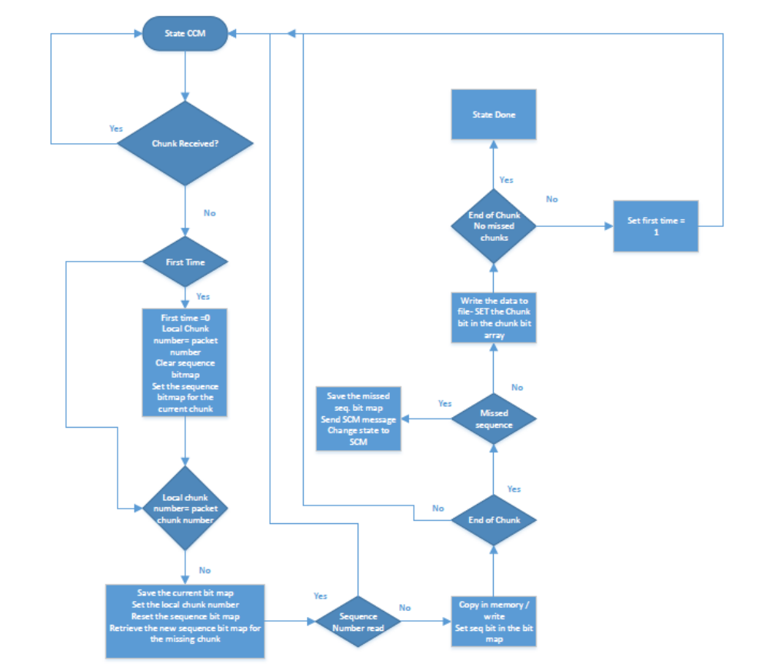

Component characteristics

Software Component <Component name>
Describe here the observed qualities of implemented component as performance, availability, modifiability, security, testability, usability)
Example:
- Performance
- Memory
- Execution time
- Code size
< Text to write >

Hardware Component <Component name>
< Text to write >

Metrics
You should describe here what metrics you use to drive your design and implementation:
- Choice of meaningful design & code metrics
- Threshold value definition for these metrics
- Reports execution on design & code
- Decisions (refactoring etc …)

We highly recommend using a tool as it is almost impossible to do it by hand.
Example usable tools: RSM, PC-Lint, Together Architect 1.1, CCCC, Code Review …

< Text to write >

Key Points and Risks

Design & implementation decisions
Log of design decision and choices
Decision | Comment

Known limitations
What will not be done
Limitation / not done | Comment

Risks
Identified risks that have to be managed in product risks management database
Risks | Comment

Objects to be produced

Software Component <Component name>
- Component deployment diagrams
How physically your software is implemented. It can be described in term of executables, libraries, data base. For embedded software it can be a description of the hardware that executes the code (processors etc …)
- Software Component directory structure (a screenshot of directory structure)

< Text to write >

Hardware Component <Component name>
< Text to write >

